First time using a printer?
You are required to login to the print services app to register.
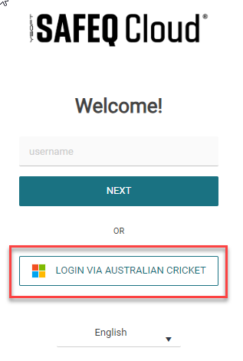
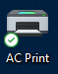
PLEASE NOTE: The new queue name is FollowMe.
- On your AC laptop double click on the icon located on your Desktop AC Print.
- Login to the SAFEQ application enter your email address as the username.
- Select LOGIN VIA AUSTRALIAN CRICKET.
For MacOS users
- Select the Printer icon on the Menu Bar
- Select Login
- Refer to step 3-4 above.
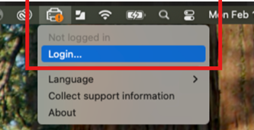
How do I register my building access card or fob on the printer?
You can use your HID building access card/fob to login to the device by scanning your card/fob (excludes WACA).
- Select a document on your CA provided laptop.
- Select File and Print.
- Select the new FollowMe print queue.
- Print the document.
- You will receive an email from scanned@cricket.com.au with a One-Time-Password (you will receive 2 emails, one with a PIN code that you can enter instead of your card).
- Record the One-Time-Password.
- Go to the printer and TAP your fob/card on the RFID reader.
- Enter your email address.
- Enter the One-Time-Password sent to you.
- Select Easy Print button on the printer home screen.
- Select the documents and select Print.
Registering your card/fob is only required once. You will be required to register a new card or fob.

Logging into the printer
There are 2 options
- Use your HID/Fob building access card, that you need to register.
- Use a PIN code

Using your HID/Fob building access card
- Select Username (1) on the printer screen.
- Scan your card/fob on the reader located on the printer.

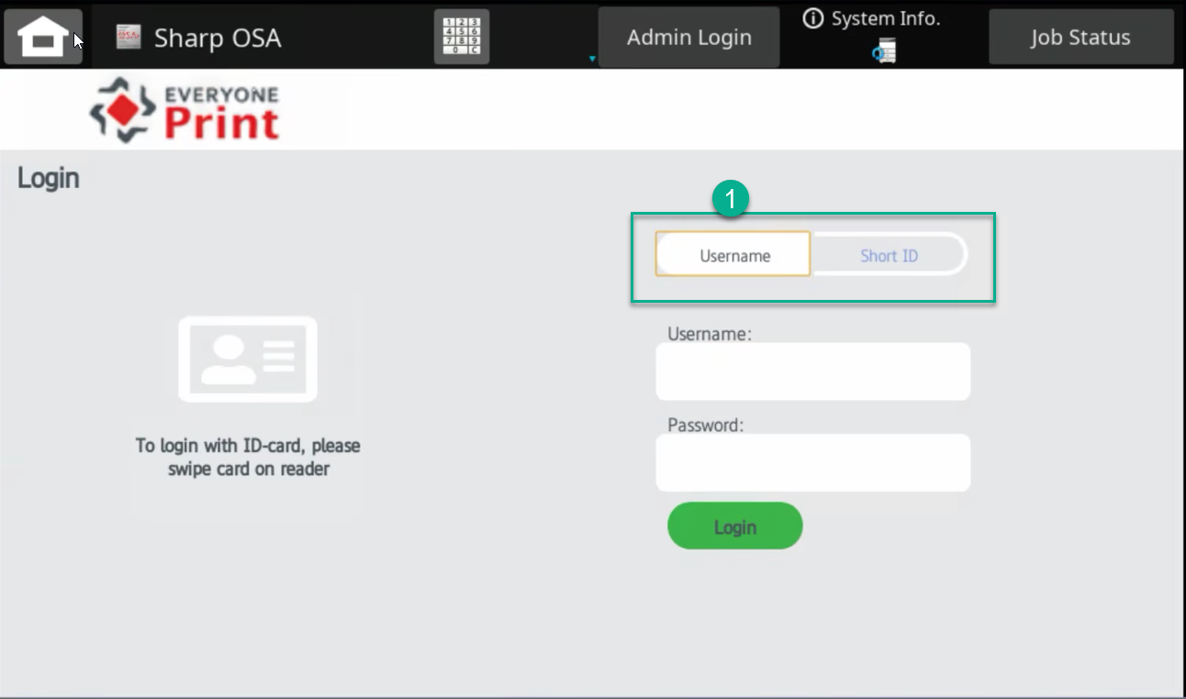
PIN Code Method
- Select Short ID (1) on the printer screen.
- Enter your PIN Code.
Print, Copy and Scan to Email
- Tap your fob/card on the RFID reader or use your PIN code (is required to be registered once).
- Select Easy Print, Easy Copy or Easy Scan and follow the instructions.

How can I generate a new code?
You can use a PIN code as an alternative to a HID card/fob, and you can obtain a PIN code as many times as you like.
- O On your AC laptop double click on the icon located on your Desktop AC Print.
- Login to the SAFEQ application enter your email address as the username.
- Select LOGIN VIA AUSTRALIAN CRICKET.
- Select Login with PIN and GENERATE NEW (2) or
- Select Login with Card to get a new code to register your HID/Fob.
For MacOS users
- Select the Printer icon on the Menu Bar
- Select Login
- Refer to step 3-4 above.
